Product
- Part of the 4 Ps framework
- Product exists at the intersection of the 3 Cs: what customers want most, what our company does best, and what our competitors struggle at.

What is a product?
Product offering can be broken down:
- Core: the product itself
- Tangible benefits outside of the core: packaging, features, branding, brand name
- Augmented benefits: installation, after sale service, delivery, intangible benefits
These three ‘levels’ of product can also be produced in different manners:
- Product item, with unique barcode i.e. one stock keeping unit
- Product line, a group of the same or similar products e.g. iphone range
  - May function in a similar manner, sold to the same customer groups, fall within a given price range
- Product mix/assortment is all products under one company name
  - All the product lines and items sold by one specific seller, i.e. iPad, iPhone, Macs

Brand and brand equity
- A brand is a promise of what to expect from the product. It is a name, term, sign, symbol, design of any combination of these. It identifies
  - Almost anything can be branded
- Value of a brand – strong brands:
  - Can increase WTP for the same product
  - Can increase probability of brand choice (Bronnenberg, 2015). Brand name is a proxy for product quality amongst uninformed buyers
  - Increase marketing communication effectiveness – less need to state aims etc
  - Increase brand name extensibility, perhaps into licensing opportunities
  - Decrease vulnerability to competitive marketing actions
  - Decrease price elasticity of demand
  - Attract and retain best employees

How do consumers benefit from brands?
- Brands identify company ownership
- Brands allow for predictable quality, thus decreasing risk of dissatisfaction
- Brands make consumer purchase decision making easier
- Brands can sever as a status symbol, giving intangible value beyond the product itself

Brand equity
Brand equity is the incremental utility consumers derive from the brand name (Kamakura, 1993). Composed of three elements:
- Brand awareness provides competitive advantages:
  - Awareness provides a sense of familiarity, thus more likely to be included in consumers’ consideration set, especially important for low involvement products
  - Creating awareness in a world of advertising is the key challenge. Can be achieved through creative, striking promotions e.g. snake on bus
- Brand loyalty, or resistance to switching, is based on:
  - Switching costs
  - Simple habits
  - Preference
  - These combine to create brand loyalty, which acts as an entry barrier and buys firms time to respond to competitive moves
- Brand associations are anything linked to a customer’s memory about a brand.
    - When a brand name is activated, nodes closest to the brand are retrieved first. Consumer satisfaction can be influenced by positivity or negativity of nearest links.
    - Network complexity can be influenced by consistency of advertising

Building a brand – 8 steps

Create brand mission
- Should focus on a limited number of goals
- Stress major policies, values, and competitive spheres of operations
- Define the competitive spheres within which the company will operate
- Take a long-term view
- These points can be effectively summarised in a positioning statement which is short, memorable, and meaningful.
  - For example Amazon’s mission “to be earth’s most customer-centric company”

Create brand personality (Akaker, 1999)
This has 5 dimensions:
- Sincerity e.g. Hallmark
  - Down to earth, honest, family-orientated, wholesome, sentimental
- Excitement e.g. Virgin
  - Daring, exciting, spirited, cool, unique, independent, contemporary
- Competence e.g. IBM
  - Reliable, secure, technical, corporate, intelligence
- Sophistication e.g. Mercedes Benz
  - Glamorous, charming, feminine, good looking
- Ruggedness e.g. Harley Davidson
  - Outdoorsy, toughness

Choose brand logo
- Logo systems are different permutations of the logo e.g. MTV has different logo styles based on the specific show
- Logo designs which communicate, overtly or covertly, the company’s product or mission, can be more effective
  - Amazon – logo shows it offers everything from A to Z
  - Google dynamic logos to deliver novel knowledge to customers
  - Baskin Robbins – famous for its 31 flavours which are incorporated into its logo

Choose brand name
- Amazon initially named Cadabra but could be misheard as cadaver, plus Amazon would appear first in alphabetical listings. Amazon also suggests scale (biggest store, biggest forest)
- HP shows initials of companies two founders

Implement brand extensions
- Leverage the brands name to get people to buy something new.
  - Line extensions increase depth by introducing a new product to a line
    - Dannon low calory versions, different flavours
  - Product mix extensions increase breadth by introducing a new product line
    - Garmin sports watch
- Benefits are providing differentiation, gaining awareness cheaply, communicate complex ideas, reduce risk for consumers to induce new consumption (due to brand strength).
  - This brand strength can also capitalise on higher favourability of evaluation

Explore co-branding
- Co-branding is where two companies form a joint venture to create a dual-branded product
- Ingredient branding: one company adds value to a host product e.g. Gore-Tex, Intel Inside
  - Used in the fashion industry e.g. Versace for H&M. Risks brand dilution for Versace. Allows H&M to test a different market segment in a less risky way

House of brands vs branded house
- House of brands has many different brands under one parent company. Used by many consumer goods companies e.g. P&G and General Motors
  - This allows better targeting as brand images do not need to be consistent – they can be specific, allowing multiple segments to be targeted.
  - Problems with one brand will not influence another brand
    - However, missed potential for synergies i.e. one brand cannot leverage another’s strengths
  - Also more difficult to build brand equity if brand awareness is lower. Requires more advertising expense. Not capitalising on increased evaluation favourability etc.
- Branded house example is Virgin, IBM – one brand for multiple different products
  - Multiproduct branding means subsequent product introductions are easier for the customer to understand and accept as they are already aware of the brand and its values
  - Stronger financial outcomes – reduced marketing costs and increased premium
  - Problems with one product affect the whole brand and therefore all other products

Renova case
- Three Cs background
- Customer – toilet paper purchase decision
- Company – medium sized, limited capital, family owned. Innovative and stylish management team
- Competitors – retailers are distribution channels as well as competitors.

Case study and further reading

Renova case study
- Idea of black toilet paper is risky as toilet paper is a highly commoditized product with sluggish growth and little innovation

Industry overview
- In 2005 the toilet paper category of disposable tissues was worth $7.6bn in Europe, and grew at 2.4% p.a. due too stagnating populations and market saturation.
  - Profitability is low, with energy prices doubling but the cost of paper pulp remining stable.
  - Renova’s European market share was less than 1%
- Renova has a 35% share in the disposable tissue category in Portugal, its home country.
  - Toilet paper prices are high in Portugal relative to Europe because of the strong power of domestic brand such as Renova.

Industry trends
- Market segmented based on quality and price. Substantial variance in package sizes, which helps companies disguise massive differences in unit prices.
  - Price, then quality then brand are the most important attributes for Portuguese customers
- Private labels – European market experience polarisation, with strong growth for premium brands, stagnation for economy brands, and growth for private labels.
  - Growth of private labels driven by improvements in quality, plus the growing power of retailers, who are consolidated and can impose pressure on suppliers.
    - Retailers carry only 2-4 brands, one of which is their own. Difficult for lower market players to secure reliable distribution and shelf placement. This gives retailers enormous power to extract higher margins from national brands
- Premium products. National brands have used technological experiments to try to counteract the growing popularity of private labels. These innovations seek to improve the most important physical aspects of toilet paper e.g. absorbency, strength and softness.
  - In Italy, one brand innovated by improving shopping and usage experience. Rolls of much greater length maintain quality whilst providing consumers with the security of a longer lasting roll.
  - Launch of moist toilet paper, which now accounts for 10% of Swiss and German markets, but only 0.1% in Portugal
    - Renova launch toilet paper impregnated with lotions.
  - Failed innovations include manufacturers who have tried to improve the aesthetics of toilet paper. Limited editions printed with Christmas or Valentine's Day motifs have never had significant sales. One exception was coloured toilet papers which were popular in the 1970s, but this trend was short lived because of environmental concerns and health concerns.

Renova branding and marketing
- CEO has wanted to shift from a disposable paper brand to a wellbeing brand. To achieve this goal, they've spent €1.5 million per year working with famous photographers to create beautiful unconventional images associating Renova with wellbeing.
  - Advertising gradually became less functional and more symbolic, featuring male nude models surrounded by toilet paper strips and rolls
- Thanks to these campaigns and its longstanding presence in Portugal, the firm has a strong brand awareness and image in its home market. This is particularly high amongst younger consumers from higher social classes.
  - Renova is perceived to be a prestige brand

The decision
- Fight private labels directly by reducing the price of its entry level paper
  - How much can they afford to reduce the price and what would be the profit implications?
- Partner with some retailers to produce private labels
  - What could Renova bring to the table, and how the organisation and its owners react to this strategy?
- Accelerate Renova's recent efforts to differentiate its toilet paper through functional innovation, improving its existing features or adding new ones
- Explore black toilet paper idea as a limited public relations coup to raise awareness and image of the Renova brand
- Launch the black toilet paper as a fully-fledged new product line and make it immediately available for purchase to the biggest number

- Decisions need to be made on pricing, packaging, communication, and distribution
- CEO wants to never lose sight of the consumers and take bold action where possible

Kotler et al. (2016)
- What are the key strategic brand management decisions?
- How do we create and manage brand identities?
- What is brand equity and how do we measure it?

The roles of brands
- Functional role of brands: relates to the actual performance of the product or service. Focus on tangible, rationally assessed product performance and benefits that satisfy practical. More prevalent in the 20th century, but nowadays we are more assured that things will work. So there has been a shift to brand management focusing on designing an emotional connection
- Emotional role of brands: building emotional ties with the customer rather than focusing on how the product works. For example Nike conveys messages about the emotions connected with winning. Emotions can play a powerful role in customers’ selection, satisfaction, and loyalty towards brands. Emotional connection transcends functional satisfaction by creating a holistic experience that delivers emotional fulfilment through a special bond with the brand (21).
- Many marketing experts believe a good brand should have both functional and emotional components. A brand promise embodies a clear value proposition and connects with people on functional and emotional levels.
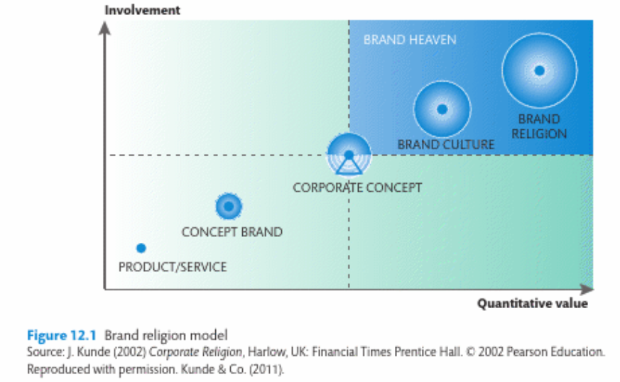

Strategic brand management decisions
- Brand management uses the implementation of marketing mix to build, measure and manage brand value (35). Strategic brand management is providing an offering with an identity understood on all levels. Includes a focus on people, both internally and externally.
  - Strategic brand management increases corporate success; 80% of companies managed with a strong brand focus had operating profits twice as high as the sector average (36, Booz Allen Hamilton).
- Important to have a brand vision that offers a clear and consistent message about the value of the brand. Brand equity is the value of the brand to the company. Brand equity increases if the right marketing processes are put in place.
  - These must communicate clear value propositions from the consumer perspective. Marketers must provide a clear direction for employees toward brand value:
    - Associate the brand in customers’ mind with a specific product or need
    - Firmly establish the brand meaning in customers’ minds
    - Elicit the proper customer responses to this brand meaning
    - Convert this brand response to a loyal relationship between customer and brand.

Brand elements
- Devices which identify and differentiate – strong brands enjoy multiple elements. There are six main criteria for choosing brand elements (names). First three build the brand, second three are about how to leverage and preserve brand equity
  - Memorable – ease of recalling and recognising. Short is better
  - Meaningful – is it suggestive of the product? Head n Shoulders
  - Likeable – how aesthetically appealing is it, visually and verbally
  - Transferable – can the element be used to introduce new products? Does it add to brand equity across geographic boundaries and market segments?
  - Adaptable – how updatable is the brand name?
  - Protectable – how legally protectable is the brand name?
- Brand slogans form a persuasive appeal that conveys something good, or reminds customers of a brand’s attributes. They often help attain humanlike personalities for the brand, which allow customers to develop emotional attachments.

Managing brand extensions
- 80-90% of new products and services introduced are brand extensions. Deciding how to brand extensions involves 3 main choices:
  - Develop new brand elements for the new product
  - Apply existing brand elements
  - Use a combination of new and existing brand elements
- Line extension – parent brand covers a new product within a product category it currently serves, such as new flavours, colours, sizes etc.
- Category extension – parent brand is used to enter a different category e.g. Honda using its company name to produce cars, motorbikes, lawnmowers etc. A successful category extension reinforces the parent brand and facilitates even more category extensions, thereby opening up more markets (52).
- Advantages of brand extensions are avoiding the difficulty and expense of establishing a new brand name. Can reduce costs by capitalising on economies of scale e.g. via identical labelling and packaging. Can also increase brand visibility when stocked together. A diverse brand portfolio means customers seeking change can obtain it without having to switch brands.

